MOSAIC EXHIBITION
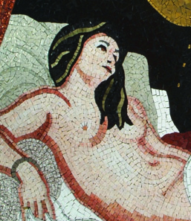

THE HUMAN FORM IN MOSAIC
by
ELAINE M GOODWIN
and
INVITED INTERNATIONAL ARTISTS

6 DECEMBER 2008 – 31 JANUARY 2009

DORSET COUNTY MUSEUM
High West Street, Dorchester DT1 1XA
http://www.dorsetcountymuseum.org/

A unique celebration of the human form in mosaic* with works inspired by mosaics from Greece, Rome and Byzantium to the present

THE ARTIST WELCOMES YOU TO THE PRIVATE VIEW ON FRIDAY 5 DECEMBER 2008
11.00 am – 1.00 pm

*The Human Form in Mosaic by Elaine M Goodwin, Crowood Press 2007
ISBN 9 781861 269812

